**Electronic CTF Portfolio Procedures and Structure**

The Portfolio *Table of Contents* below lists the17 folders/sections and the expected files within each of the 17 folders.

The first two folders (1 and 2) provide an overview about you and the Portfolio. Folders 3 – 16 show evidence of how you have used the ToP methods in **events** you have designed and facilitated. Folder 17 asks for three short essays on aspects of facilitation where understanding and insight are important to facilitator effectiveness.

In order for your Primary Mentor and CTF Assessors to most easily track your examples of work, please create files exactly as described in the *Table of Contents* and include each item listed.

Please prepare your files as WORD documents or pdf files.

The complete portfolio will need to be delivered in total to the National CTF Coordinator **two weeks prior** to the assessment interview. You may send it as one of the following: 1) a shared Dropbox file; 2) a zip file; 3) single WORD document with (hyperlinked) imbedded documents. You may view a sample Electronic CTF Portfolio folder/file system*:* [*Sample Electronic Portfolio*](https://www.dropbox.com/sh/a2syhwkmiojo8wt/AAC_BfqS_B-PY3t-JM1Fc0Hta?dl=0)

You may select an event such as a *Focused Conversation* from another event (for instance, the large project or strategic planning) and include it in another section of your Portfolio; however, please extract and copy it into a separate file. It is not the task of the assessor to search and find a *Focused Conversation* within a larger project file but for you to pull it out of the larger file and include it in the appropriate file with the supporting work.

To start preparing your Portfolio, identify what work you want to include to provide the best evidence for the files listed.

While the facilitation events you select provide evidence of competency 4.0 – *Uses ToP Methods Effectively*, you will also use them to illustrate your mastery of Competencies 1-3 and 5-7 ([Certification Guide](https://icausa.memberclicks.net/assets/docs/ctf%20guide%20revised%201-15.pdf) – pp. 9–18). Describe the location of your examples in column 5 on the Competencies Checklist, where it asks for a portfolio page #. Please list both the file # and page within that file to demonstrate the particular competency. It is appropriate to list more than one example in column 5.

If you have questions, please review them with your Primary Mentor or contact the Certification Coordinator, Marilyn Oyler, [marilyn.oyler@gmail.com](mailto:marilyn.oyler@gmail.com) or (602) 460-0605.

There may be some circumstances where a Candidate may need/want to submit a Portfolio in paper rather than electronically (or parts of a Portfolio). If this is the case the Candidate should talk with the CTF Coordinator to explore options.

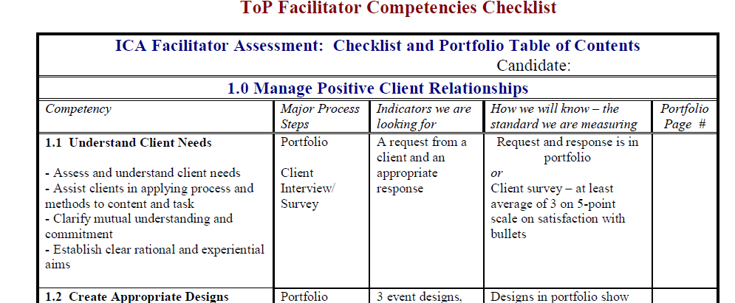

3.1,

12.3,

6.1

**3.1 p.1,**

**10.1 p.1,**

**8.1 p.1**

**PORTFOLIO - TABLE OF CONTENTS**

|  |  |
| --- | --- |
| **Folder 1** | **Introduction to the Portfolio**  1.2 Cover Page with Name and Contact Information  1.2 Table of Contents  1.3 CTF Competencies (pp. x-x in Certification Guide – fill in file names in column “Portfolio File/Page #”) as your last step of preparation of your Portfolio. |
| **Folder 2** | **Autobiography & Facilitation Journey**  These may be combined into a single file or two files  2.1 Autobiography  2.2 Facilitation Journey |
| **Folder 3** | **Substantial Project (illustrates multiple methods and client interaction)**  3.1 Context about situation/client/event  3.2 Event Design  3.3 Event Documentation  3.4 Event Reflection Sheet  3.5 Participant Evaluations  3.6 Other documents related to this Event |
| **Folder 4** | **Focused Conversation 1**  4.1 Context about situation/client (optional)  4.2 Design  4.3 Documentation (optional)  4.4 Reflection Sheet about FC 1  4.5 Other documents (optional) |
| **Folder 5** | **Focused Conversation 2**  5.1 Context about situation/client (optional)  5.2 Design  5.3 Documentation (optional)  5.4 Reflection Sheet about FC2  5.5 Other documents (optional) |
| **Folder 6** | **Focused Conversation 3**  6.1 Context about situation/client (optional)  6.2 Design  6.3 Documentation (optional)  6.4 Reflection Sheet about FC3  6.5 Other documents (optional) |
| **Folder 7** | **Consensus Workshop 1**  7.1 Context about situation/client  7.2 Design  7.3 Documentation of Consensus Workshop  7.4 Reflection Sheet about CW1  7.5 Other documents (optional) |
| **Folder 8** | **Consensus Workshop 2**  8.1 Context about situation/client  8.2 Design  8.3 Documentation of Consensus Workshop  8.4 Reflection Sheet about CW2  8.5 Other documents (optional) |
| **Folder 9** | **Consensus Workshop 3**  9.1 Context about situation/client  9.2 Design  9.3 Documentation of Consensus Workshop  9.4 Reflection Sheet about CW3  9.5 Other documents (optional) |
| **Folder 10** | **Action Planning**  10.1 Context about situation/client  10.2 Action Planning Design  10.3 Action Planning Documentation  10.4 Action Planning Reflection Sheet  10.5 Other documents related to this Action Planning event |
| **Folder 11** | **Strategic Planning**  11.1 Context about situation/client  11.2 Strategic Planning Design  11.3 Strategic Planning Documentation  11.4 Strategic Planning Reflection Sheet  11.5 Other documents related to this Strategic Planning event |
| **Folder 12** | **Wall of Wonder**  12.1 Context about situation/client  12.2 WOW Design  11.3 WOW Documentation  11.4 WOW Reflection Sheet  11.5 Other documents related to this WOW event |
| **Folder 13** | **Large Group Event** (or clear reference to another file which meets this criteria)  13.1 Context about situation/client/event  13.2 Large Event Design  13.3 Large Event Documentation  13.4 Large Event Reflection Sheet  13.5 Other documents related to this Large Group Event |
| **Folder 14** | **Small Group Event** (or clear reference to another file which meets this criteria)  14.1 Context about situation/client/event  14.2 Small Event Design  14.3 Small Event Documentation  14.4 Small Event Reflection Sheet  14.5 Other documents related to this Small Group Event |
| **Folder 15** | **Event Designed for Multiple Learning Styles**  15.1 Context about situation/client/event  15.2 Event Design  15.3 Event Documentation  15.4 Event Reflection Sheet  15.5 Other documents related to this Event |
| **Folder 16** | **Co-Facilitated Event**  16.1 Context about situation/client/event  16.2 Event Design  16.3 Event Documentation  16.4 Co-facilitator Event Reflection sheet  16.5 Event Reflection Sheet  16.6 Other documents related to this Event |
| **Folder 17** | **Evidence of Understanding**  17.1 Work Over Time with Client  17.2 Human Change  17.3 Ethical Dilemma |